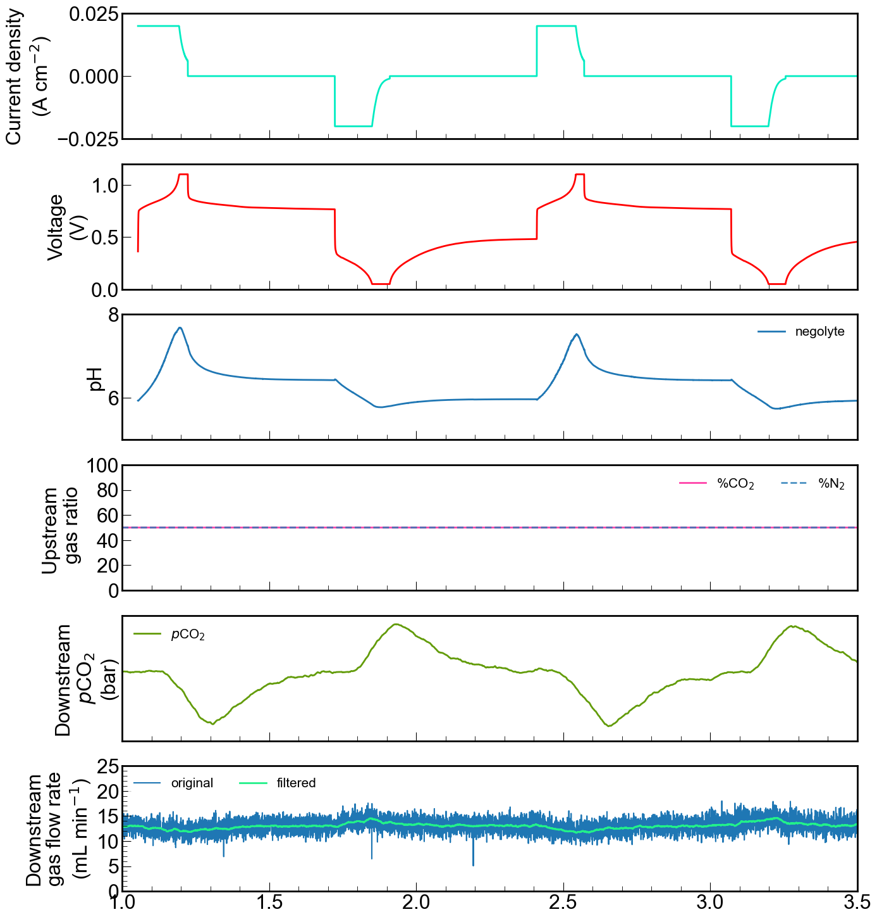

Rest

Rest

Discharge

Charge

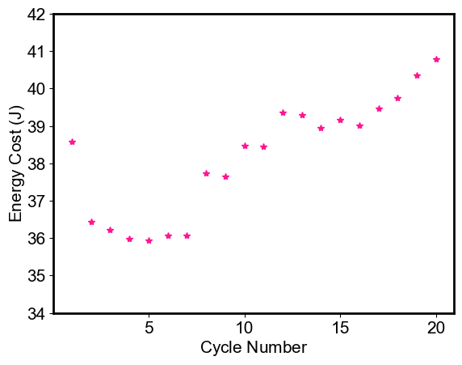

**Energy Cost, cycle 1 = 38.58 Joule**

**Energy Cost, cycle 20= 40.78 Joule**

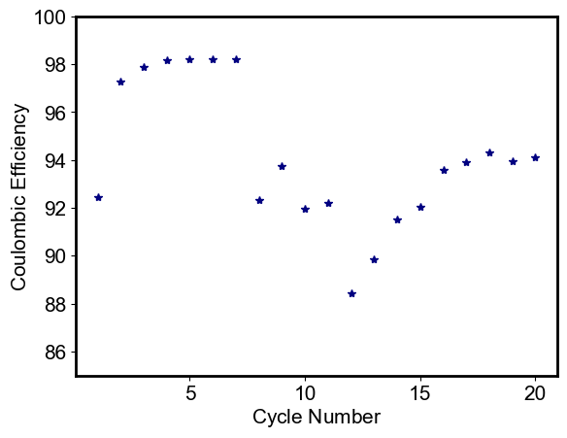

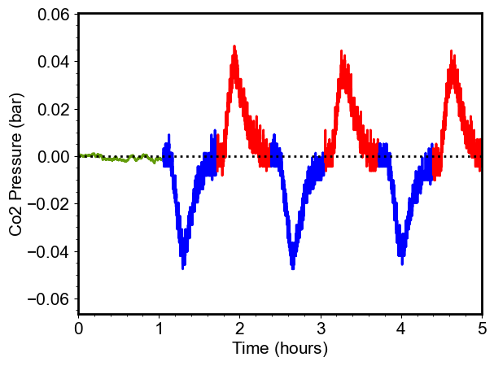

Amount of captured based in integration under the curve 0.01